Everywhere = Nowhere = Now

Omar Hamzah Saiyed
40355015
Aran Scherzer
40xxxx

GitHub: https://github.com/docomomomo/CART360_MainProject

Project Overview
Gesture Communication Glove
This project explores the use of wearable technology as a tangible interface to assist communication for people who are deaf, mute or otherwise unable to speak easily. The design takes the form of a glove with sensors that detect finger positions. Different combinations of fingers bent or extended act as inputs which are interpreted by a microcontroller and translated into words or phrases that can be spoken through a speaker and displayed as text.
The project focuses on creating a system where communication happens directly through gesture rather than typing or using a phone. By translating hand movements into speech and text, the glove acts as a bridge between physical expression and digital communication. The design explores how wearable electronics can extend the human body as an interface and reduce communication barriers in everyday environments.

The Four Questions
Context and Environment
This project is intended for everyday social environments where communication barriers frequently occur. These environments may include public spaces, classrooms, stores, public transport or conversations with others.
The primary users are people who are deaf, mute or non-verbal, as well as individuals who may have temporary or other speech impairments. The glove allows them to communicate quickly with people who may not understand sign language or other forms of communication.
Relationship Between Users and the Artifact
The relationship between the user and the artifact is designed to feel intuitive and natural. Instead of interacting with a keyboard or screen, the user communicates through movements of their hand.
The glove acts as an extension of the user’s body. It detects gestures and immediately translates them into language. This creates a relationship where the artifact supports the user’s intention without requiring complex interaction.
For observers, the experience may highlight how communication barriers exist in everyday life and how small technological interventions can change the way people interact with each other.
The Notion of Empowerment
The project focuses on empowerment by providing users with an alternative way to communicate that is independent and immediate.
Many assistive communication tools require external devices or assistance from others. By integrating the technology into a wearable object, the glove allows users to communicate in a less intrusive way.
The project also raises questions about accessibility in design and how environments often assume that everyone communicates in the same way. By addressing this gap, the artifact aims to challenge those assumptions and explore more inclusive forms of human interaction.
Communicating Intentions Through Interaction Design
The interaction design strategy of the project focuses on translating gesture into communication through a tangible interface.
The glove communicates its purpose through its physical design and behaviour. The sensors embedded in the glove fingers allow the device to respond directly to finger movements, making the interaction feel immediate and responsive. The project aims to express the idea that technology can act as a bridge between people rather than simply being a tool by turning gestures into spoken words and text. This design demonstrates how physical computing systems can support human expression and connection.

The Design
The Story
The story behind the design comes from the idea that many aspects of society are built around the assumption that everyone can speak and communicate in the same way. For people who are deaf, mute or have speech impairments, everyday interactions such as ordering food, asking for help or speaking to strangers can become difficult because most people would find it difficult to understand or do not know sign language.
This project aims to explore how a simple wearable interface could help bridge that communication gap. Instead of requiring other people to learn sign language, the glove translates hand gestures into spoken language and text, allowing users to communicate more easily with the people around them.
The project is motivated by the idea that technology can help make environments more accessible and inclusive rather than forcing people to adapt to systems that were never designed for them.
The Personality
The personality of the design can be described as supportive, responsive and assistive. The glove quietly listens to the user’s gestures and translates them into communication without requiring distractive inputs and complicated controls. This personality is reflected in the physical form of the object. Because it is worn on the hand and responds directly to finger movements, the interaction feels personal and integrated with the body where the glove behaves more like a translator that helps to express the user’s intentions.
The Emotions
The design aims to evoke feelings of inclusion and connection. For users who struggle to communicate verbally, the glove may create a sense of relief, confidence and independence because it allows them to express themselves more easily. For people interacting with someone using the glove, the experience may also create awareness of communication barriers that are often invisible.
The emotional response may vary depending on the person’s perspective. For some it may feel empowering, while for others it may encourage reflection on how technology can help make society more accessible.

The Big Why
The project exists to explore how physical computing and wearable technology can help people who may be disadvantaged by systems that rely heavily on spoken communication. Many assistive communication technologies rely on smartphones or text-to-speech devices which can be slow or socially awkward to use in everyday situations. By embedding the interaction directly into a wearable object like a glove, communication becomes more immediate and natural. The project is not meant to replace sign language, but instead to act as a translation layer between gesture and speech that helps bridge communication between people who know sign language and those who do not. The glove also allows a degree of personalisation. If people have impaired movement in their hands, they can personalise the gestures to mean different things depending on their needs
The glove also allows a degree of personalisation depending on the user’s needs. Not everyone who experiences communication barriers has the same level of mobility or hand control. Some people may not be able to perform complex hand gestures or full sign language due to limited movement or other physical constraints. Because the system is based on simple finger combinations rather than fixed sign language gestures, users can personalise which gestures correspond to specific words or phrases. This allows the interaction to adapt to the user rather than forcing the user to adapt to the system. For example, if someone is unable to move certain fingers or perform complex signs, they can assign words to gestures that are easier for them to perform. This flexibility makes the system more inclusive and allows the device to support a wider range of communication needs.

Interaction Design Strategy
The project is built around a system that converts physical gestures into digital communication.
Each finger of the glove contains a sensor that detects whether the finger is bent or extended. These sensors provide input to a microcontroller which interprets the finger positions as combinations. Each combination corresponds to a specific word or phrase.
The interaction system operates through several stages:
- Physical interaction – The user bends or extends their fingers to create a gesture.
- Sensor detection – Flex sensors detect the position of each finger.
- Digital interpretation – The microcontroller processes the finger combination.
- Output feedback – The corresponding word or phrase is spoken through a speaker and displayed as text.
This creates a multi-layered interaction system where the body becomes an input device and the glove acts as a mediator between gesture and language.
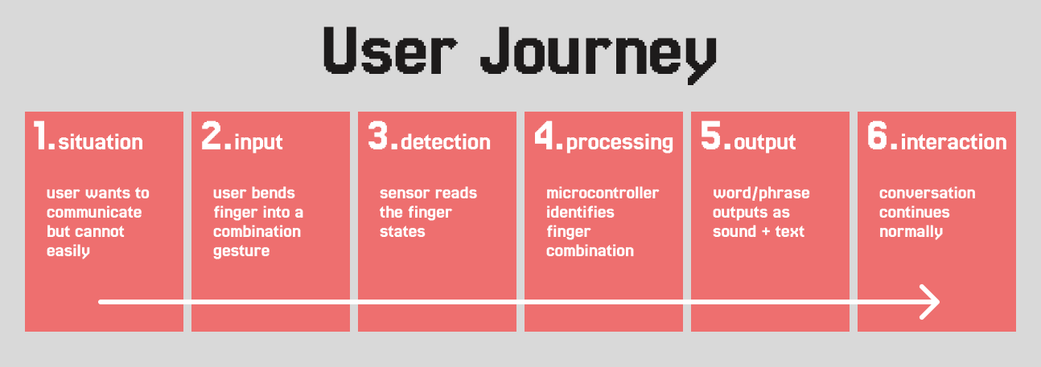
User Journey Map

An Evaluation of Sensors
The project explores two possible sensor approaches for detecting finger gestures. These are flex sensors attached to fingers and mechanical push buttons embedded in the palm.
Flex sensors can detect how much a finger bends by measuring the degree of curvature along the finger. Their main affordance is that they respond directly to natural finger movement, allowing the glove to detect gestures without requiring the user to press anything. This creates a very natural interaction where the system simply listens to the motion of the hand. However flex sensors measure a range of bending angles rather than a simple on/off state, which means interpreting gestures can be less precise and may require calibration to distinguish between finger positions.
As an alternative, the design also considers the use of small push buttons placed in the palm of the glove. When the user closes their fingers, each finger presses a corresponding button. The affordance of this approach is reliability and clarity of input, as buttons provide a clear binary state (pressed or not pressed). This makes gesture detection simpler and more consistent, especially for combinations of fingers that represent specific words or phrases.
Both sensing approaches support the project’s interaction design strategy of translating finger combinations into communication. Flex sensors prioritise natural gesture detection, while palm buttons prioritise precision and reliability of input. Testing both approaches during prototyping will help determine which method better supports the intended interaction and usability of the device.

Related Works
SignAloud Gloves
SignAloud gloves were developed by students at the University of Washington as a wearable system that translates American Sign Language into spoken words. The gloves use sensors placed along the fingers and hands to detect movements and gestures. The sensor data is interpreted by software that recognises specific sign language patterns and converts them into speech through a speaker. This project demonstrates how wearable sensor systems can translate physical gestures into digital communication. It focuses on bridging the communication gap between people who use sign language and those who do not understand it.
Ava App
The Ava app is a mobile application designed to assist deaf and hearing impaired individuals by providing real-time captions of spoken conversations. The app listens to conversations through a smartphone microphone and converts speech using speech recognition technology into live text that appears on the screen. This allows users to follow conversations in group settings, meetings or everyday interactions. The project demonstrates how software and artificial intelligence can help improve accessibility by translating spoken communication into a readable format.
SoundShirt
The SoundShirt is a wearable garment that translates sound into vibrations felt across the body. It was developed to help deaf and hearing impaired individuals experience music and sound through physical sensations. Small actuators embedded in the fabric convert audio signals into tactile feedback across different parts of the shirt. Unlike the other two projects that translate for speech, the SoundShirt explores another form of sensory communication by converting audio information into touch. The project demonstrates how wearable technology can create new ways for people to experience and interact with sound.
The Difference
While many existing projects focus on translating sign language gestures or spoken conversation, this project explores a different approach by using simplified finger combinations as a communication system. Instead of interpreting complex sign language movements or relying on speech recognition, the glove detects simple finger states that represent words or phrases. This approach simplifies the sensing and recognition process while still enabling effective communication. By focusing on commonly used words and phrases, the system prioritises speed, reliability, and accessibility rather than attempting to interpret the full complexity of sign language. Because the gestures are customizable, users can assign words to movements that are comfortable for them to perform, making the system more accessible for individuals with different levels of hand mobility.
The goal of this project is not to replace sign language, but to explore a simpler and more adaptable wearable communication interface that can help bridge communication barriers in everyday interactions.

